<https://www.nytimes.com/1981/04/23/business/quest-magazine-put-up-for-sale-by-worldwide-church-group.html>

[**ARCHIVES**](http://timesmachine.nytimes.com/browser) | 1981

***QUEST MAGAZINE PUT UP FOR SALE BY WORLDWIDE CHURCH GROUP***

APRIL 23, 1981

***About the Archive***

*This is a digitized version of an article from The Times’s print archive, before the start of online publication in 1996. To preserve these articles as they originally appeared, The Times does not alter, edit or update them.*

*Occasionally the digitization process introduces transcription errors or other problems. Please send reports of such problems to*[*archive\_feedback@nytimes.com.*](mailto:archive_feedback@nytimes.com)

[[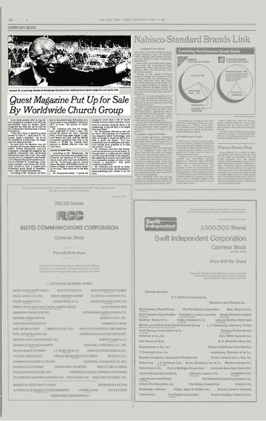](https://timesmachine.nytimes.com/timesmachine/1981/04/23/094691.html)](https://timesmachine.nytimes.com/timesmachine/1981/04/23/094691.html" \t "_blank)

**[VIEW PAGE IN TIMESMACHINE](https://timesmachine.nytimes.com/timesmachine/1981/04/23/094691.html" \t "_blank)**

April 23, 1981, Page 00004The New York Times Archives

Some three months after its top editors resigned in a dispute over editorial interference from its owners, Quest magazine has been put up for sale by the Ambassador International Cultural Foundation.

''They don't want to spend any more money to build it,'' said Lewis W. Gillenson, Quest's publisher. ''So far as the foundation is concerned, the magazine has used up its time.''

He said that the decision was not caused by the January departure of the editor, Robert Shnayerson, and five colleagues, although the magazine has suffered circulation and advertising difficulties since that event. The resignations were in response to the foundation's demand that Quest publish an article by Herbert W. Armstrong, a California minister who heads the Worldwide Church of God, a conservative Protestant group based in Pasadena, Calif., that created the foundation.

According to Mr. Gillenson, the foundation has plowed about $15 million into Quest since it was founded in February 1977 to cover ''the pursuit of excellence.''

Mr. Gillenson said that the magazine, published 10 times a year, lost nearly $3 million last year. Through May, advertising pages lagged 11 percent behind last year, and the 330,000 circulation guarantee that was to be raised to 375,000 has instead been shaved to 300,000 effective with the June issue. Article on Sadat Plan

According to Mr. Shnayerson, the decision to sell Quest was probably hastened by the departure of the editors, which came after they were ordered to run Mr. Armstrong's positive article about the plans of President Anwar el-Sadat of Egypt to build a peace center in the Sinai. The article ran in the May issue.

Mr. Shnayerson added: ''I guess the magazine never had a lot of warm friends with the church, because it was kind of a peculiar thing for them to be supporting. It may be that it no longer has any friends.''

Mr. Shnayerson, who has a new job as editor and publisher of a forthcoming magazine called Technology, said that he thought it would be difficult to find a buyer for Quest. ''It's surrounded by a lot of confusion and whatever shards have attached to it from the church,'' he said.

Mr. Gillenson said that the foundation had not yet set a price for Quest, although there is a subscription liability of more than $2 million to be assumed. He added that if a buyer were not found in a reasonable amount of time, it was ''always a possibility'' that Quest would be closed down.

Mr. Gillenson also serves as president of Everest House, the foundation's book publishing unit, which is not for sale.

A version of this article appears in print on April 23, 1981, on Page D00004 of the National edition with the headline: QUEST MAGAZINE PUT UP FOR SALE BY WORLDWIDE CHURCH GROUP. [Order Reprints](http://www.nytreprints.com/)| [Today's Paper](http://www.nytimes.com/pages/todayspaper/index.html)|[Subscribe](http://www.nytimes.com/subscriptions/Multiproduct/lp839RF.html?campaignId=48JQY)